Abstract
Medical databases are increasing rapidly in size and numbers but most of these data are not analyzed for finding the valuable and hidden knowledge. Advanced data Science techniques (Machine Learning) can be used to discover hidden patterns and relationships. Models developed from these techniques are useful for medical practitioners to make right decisions. The present research studied the application of two machine learning techniques i.e. support vector machine and artificial neural networks to ascertain the efficacy of predictive models for breast cancer recurrence using dataset from the Wisconsin breast Cancer Database. The performance of both classification techniques was evaluated in order to determine the most efficient and effective model. The Support vector machine (SVM) model showed a higher accuracy with lower error rates compared to that of the artificial neural network model while the evaluation criteria proved the ANN to be a more effective and efficient classification techniques for the prediction of breast cancer recurrence.
Keywords: Classification; Machine learning; Support vector machine; Artificial Neural Networks.

1.Introduction
The risk of getting breast cancer goes up with age. In the United States, the average age when women are diagnosed with breast cancer is 61. Men who get breast cancer are diagnosed usually between 60 and 70 years old. Early detection and proper diagnoses can go a long way in reducing the treatment efficacy, incidence and mortality rate un the world. Breast cancer (BC) is the most common cancer in women, affecting about 10% of all women at some stages of their life. In recent years, the incidence rate keeps increasing and data show that the survival rate is 88% after five years from diagnosis and 80% after 10 years from diagnosis [1]. Early prediction of breast cancer is one of the most crucial works in the follow-up process in try to curb the disease incidence and data mining methods can help to reduce the number of false positive and false negative decisions [2]. Consequently, new methods such as knowledge discovery in databases (KDD) has become a popular research tool for medical researchers who try to identify and exploit patterns and relationships among large number of variables and predict the outcome of a disease using historical cases stored in datasets [3]. In this paper, using Machine learning techniques, I developed two predictive models to predict the recurrence of breast cancer by analyzing data collected from Wisconsin Diagnostic Breast Cancer (WDBC) registry. The next sections of this paper review related work, described in the background of this study, modelling two classification models (Support Vector Machine, and Artificial neural network (ANN), explain the methodology used to conduct the prediction, present experimental results, and the last part of the paper is the conclusion. To estimate validation of the models, accuracy, sensitivity, and specificity were used as criteria, and were compared. This work was carried out with the help of R project data mining tool which is an open source tool used for several model building purposes in predictive analytics.
2. Previous research
Classification is one of the most important and essential tasks in machine learning and data mining. About a lot of research has been conducted to apply data mining and machine learning algorithms on different medical datasets to classify breast Cancer. In the following paragraph is a review of such works.
In 2012, Gouda I. Salama et al, have presented a comparison among the different classifiers decision tree (J48), Naïve Bayes (NB), Multi-Layer Perception (MLP), Sequential Minimal Optimization (SMO) and Instance Based for K-Nearest neighbor (IBK) on three very popular different databases of breast cancer (Wisconsin Breast Cancer (WBC),Wisconsin Prognosis Breast Cancer (WDBC) and Wisconsin Diagnosis Breast Cancer (WDBC)) by using confusion matrix and classification accuracy based on 10-fold cross validation method. The experimental results showed that in the classification using fusion of J48 and MLP with the PCA was superior to the other classifiers using WBC data set [4]. In December 2016, Sadhana and Sankareswari proposed the comparison of accuracies for the two classifiers (SVM, Decision Tree) for WDBC based on 10-fold cross validation as a test method. The accuracy of SVM is the best classifier and the accuracy obtained by decision tree is better than that produced by SVM [5].
In March 2009, Shukla et.al [11] examined a knowledge-based system for early diagnosis of breast cancer using Artificial Neural Networks (ANN) and Neuro fuzzy system. The performance measures considered were accuracy of diagnosis, training time, No. of neurons and No. of epochs. Simulation results show that this knowledge-based system enhanced the survival rates effectively [6]. In 2007, Polat & Güneş proposed LS-SVM classifier algorithm for the diagnosis of breast cancer and achieved the classification accuracy of 98.53% using 10-fold cross validation [7]. In January 2009, Akay et.al proposed a new method for the breast cancer diagnosis using support vector classification algorithm on the most predictive features and obtain the classification accuracies of 99.02% without cross-validation [8]. In February 2013, Yeh et al. present an innovative technique for breast cancer detection, by using statistical methods in combination with swarm optimization and reported the accuracy of 98.71% [9]. In January 2011, Marcano-Cede~no et al. proposed a new method AMMLP for the classification of breast cancer datasets by using an Artificial Neural Network over the biological metaplasticity property and acquire classification accuracy of 99.26 [10].
2.1. Data Cleaning and Preprocessing
Data cleaning and preprocessing tasks are performed to reduce noise and increase the consistency of data. The preprocessing steps most addressed in the reviewed research works were normalization/standardization of data and missing data handling. Two simple ways of data preprocessing are normalization (Min-Max transformation) and standardization (Z-Score transformation) [Suarez-Alvarez et al. 2012]. Normalization refers to the feature scaling between its minimum and maximum values, while standardization rescales the features so that they follow a standard normal distribution (zero mean and unitary standard deviation). The objective of normalization/standardization is to make features with different scales and ranges of measurement (e.g., age, hemoglobin values) comparable, so that none has more influence than the others on classification task [Shalabi and Shaaban 2006].
3. Methodology
R project was used to implement the machine learning algorithms in this study, with the aid of other scientific computing libraries: The e1071 Package – This package was the first implementation of SVM in R. The svm() function in e1071 provides a rigid interface to libsvm by using visualization and parameter tuning methods, neuralnet and Data Explorer [11].
To determine the effectiveness of each machine learning technique in predicting breast recurrence, I made use of trained Wisconsin Diagnostic Breast Cancer (WDBC) dataset [12]. The dataset consists of features which were computed from a digitized image of a fine needle aspirate (FNA) of a breast mass. The said features describe the characteristics of the cell nuclei found in the image [12, 13]. In this paper, I have investigated two Machine learning techniques: the support vector machine and the artificial neural networks and I used these algorithms to determine the effectiveness to predict the recurrence rate of WDBC data set. I selected these two classification techniques to find the most suitable one for predicting cancer recurrence rate and for its popularity by many other reearchers using same dataset(WBDC).
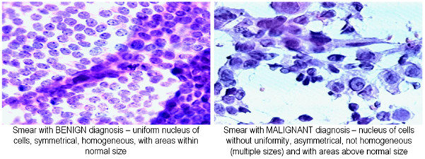
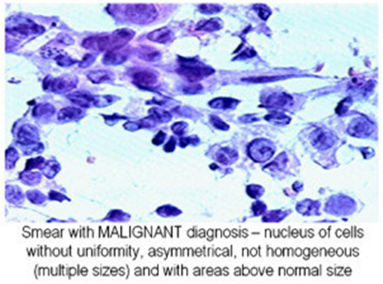

Figure 1: Digitized images of FNA: (a) Benign, (b) Malignant.[4]
2.1 The training Dataset discription
The Wisconsin Breast Cancer (original) datasets from the UCI Machine Learning Repository has 569 data points in the dataset divided into 2 classes: Malignant with 212 data points and benign with 357 data points respectively. The dataset has the following features :(1) radius, (2) texture, (3) perimeter, (4) area, (5) smoothness, (6) compactness, (7) concavity, (8) concave points, (9) symmetry, and (10) fractal dimension. With each feature having three information [12].
For each characteristic three measures are given:(1) mean, (2) standard error, and (3) “worst” or largest (mean of the three largest values) computed. Thus, having a total of 30 dataset features.

2.2 Feature selection
The generic algorithms on WDBC data set for future selection and generation is discussed below.
2.2.1 Principal Component Analysis (PCA)
Principal Component Analysis (PCA) is a mathematical procedure that uses an orthogonal transformation to convert a set of observations of possibly correlated variables into a set of values of linearly uncorrelated variables called principal components. The number of principal components is less than or equal to the number of original variables. To get an idea about the dimensionality and variance of the dataset, I am first looking at PCA plots for samples and features. For many model fitting algorithms, these variables are much easier to fit than “natural” (somewhat collinear, somewhat correlated, not-independent) variables [17].

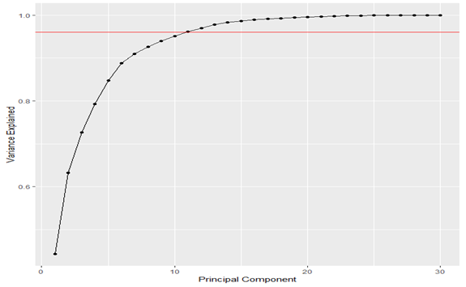
Plot of the proportion of variance explain as a function of the number of principal components

From the above plot, I need 11 principal components to explain more than 0.96 of the variances and 20 to explain more than 0.99. The features with highest dimensions or aligned with the leading principal component are the ones with highest variance.

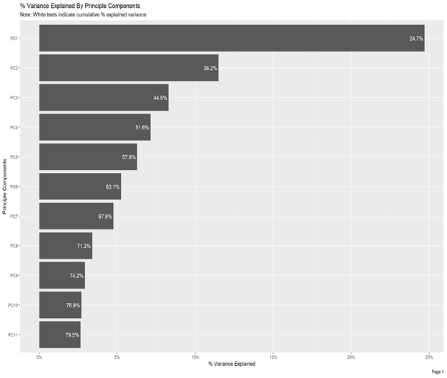

2.2.2 Creating training and test sets of Data.
Before doing anything else with the data, splitting the datasets into train and test is very important. Performing feature selection on the whole dataset would lead to prediction bias, I therefore need to run the whole modeling process on the training data alone.
There were two phases of experiment for this study: (1) training phase, and (2) test phase. The dataset was partitioned by 70% (training phase) and 30% (testing phase).
2.3.2 Training and Classification
After getting the PCA of my data as above, I decided to retrieve the loadings for the first eleven principal components and transformed the data using the loadings. Notice that there are only seven columns in the transformed test i.e instead of using the original 30 features, I instead use the seven principal components reducing the dimensionality of the feature space. Also, the original 30 features had severe multicollinearity problems. The eleven principal components I used as features have zero correlation by design, eliminating our multicollinearity problem.
I transformed the test set features using the same loadings I estimated from the training data because if I redid principal component analysis on the test set features I would have a poor accuracy rate. If I did principal component analysis and then created a test set from the transformed matrix then I would have a higher accuracy rate, then I should. I had to must estimate the principal components from the training data and then apply the same transformation to the test set data. This creates a plot of the proportion of variance explained as a function of the number of principal components as seen below. Most of the features in dataset are very distinct as in the PCA plots, therefore no point plotting hierarchical clustering dendrograms.

3.0 Machine Learning Algorithms.
Machine Learning is a branch of Artificial Intelligence that relates the problem of learning from data samples to the general concept of inference [13]. Every learning process consists of two phases: (i) estimation of unknown dependencies in a system from a given dataset and (ii) use of estimated dependencies to predict new outputs of the system. The task of classification refers to a learning process that categorizes the data into a set of finite classes. [ 14]. In this paper, I used Support vector machine (SVM) and artificial neural networks (ANN) machine learning algorithms to determine its efficacy in the prediction of breast cancer recurrence and conclude on which method performs better.
3.1. Support vector machine
Support Vector Machine (SVM) was introduced by Vapnik et al. [16] it is a very powerful method that has been applied in a wide variety of applications. The basic concept in SVM is the hyper plane classifier, or linear separability. Two basic ideas are applied to achieve linear separability, SVM: margin maximization and kernels that is, mapping input space to a higher-dimension space (or feature space). SVM projects the input data into a kernel space. Then it builds a linear model in this kernel space. A classification SVM model attempts to separate the target classes with the widest possible margin. A regression SVM model tries to find a continuous function such that maximum number of data points lie within an epsilon-wide tube around it. Different types of kernels and different kernel parameter choices can produce a variety of decision boundaries (classification) or function approximators (regression). SVM has been used in a range of problems and they have already been successful in pattern recognition in bioinformatics, cancer diagnosis and more [16,17].
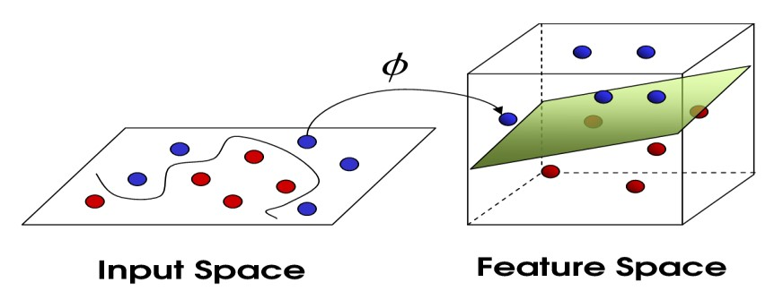
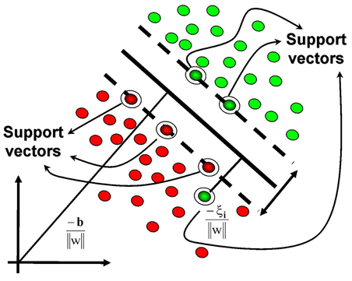
Fig 1a b shows SVM topology in hyperspace.
Support Vector Machine is a maximum margin classification algorithm rooted in statistical learning theory. It is the method for classifying both linear and non-linear data. It uses a non-linear mapping technique to transform the original training data into a higher dimension. It performs classification tasks by maximizing the margin separating both classes while minimizing the classification errors [17]
3.2. Artificial Neural Networks (ANN)].
The Multilayer Perceptron (MLP), a feed-forward backpropagation network, is the most frequently used neural network technique in pattern recognition [19] [20]. Briefly, MLPs are supervised learning classifiers that consist of an input layer, an output layer, and one or more hidden layers that extract useful information during learning and assign modifiable weighting coefficients to components of the input layers. Fig. 3 depicts the previous words. In the first (forward) pass, weights assigned to the input units and the nodes in the hidden layers and between the nodes in the hidden layer and the output, determine the output. The output is compared with the target output. An error signal is then back propagated and the connection weights are adjusted correspondingly. During training, MLPs construct a multidimensional space, defined by the activation of the hidden nodes, so that the three classes (malignant, benign and normal tissue) are as separable as possible. The separating surface adapts to the data.
Below is a Diagrammatic illustration of neural networks generated from my data.
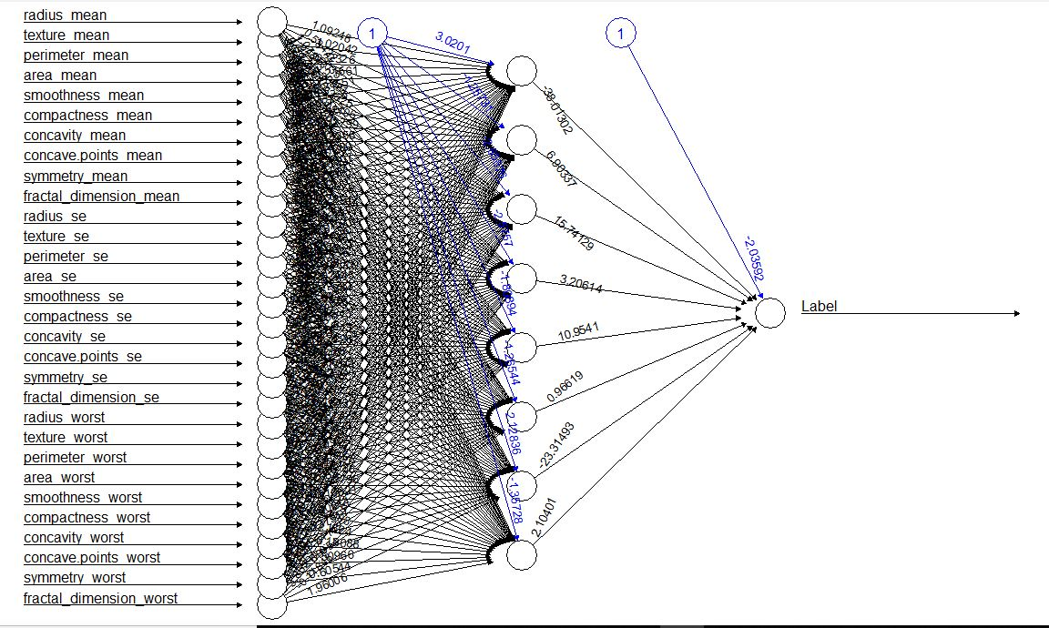

Fig 2a & b shows MLP feed forward Neural Network.
3.3 Evaluation Performance
Once the predictive models are built, I verify how efficiency. For that, I compare the accuracy measures based on, TP rate and FP rate values for SVM and ANN as shown in Table 1. Since Confusion matrices represent a useful way for evaluating classifier, each row of Table 1 represents rates in an actual class while each column shows predictions. After creating the predicted model, results obtained in evaluating efficiency of our algorithms is analyzed. Table 1
  - Data Description:
Wisconsin Diagnostic Breast Cancer (WDBC) (1995) dataset contains 569 instances (62.74% benign, 37.26% malignant), and has 32 patient attributes, which includes 1 patient ID number record, 30 tumor diagnosis information, and 1 tumor diagnosis result record (benign and malignant). The tumor diagnosis information in the data set is collected from 10 aspects, and for each attribution, three measure results are given, i.e., mean, standard error, and largest value, which results in 30 feature records in the data set. Summary of the data structure is given in Table 2.
Table 1: Wisconsin Diagnostic Breast Cancer Dataset
Dataset Attribute Instances class
WDBC 32 569 2

Table 1

For the computation of every cell nucleus, different feature values are taken i.e. ten real-valued
Table 2: features of WDBC Data set

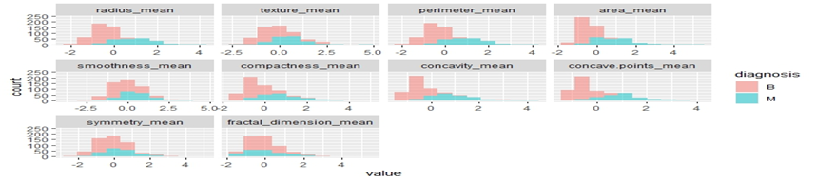
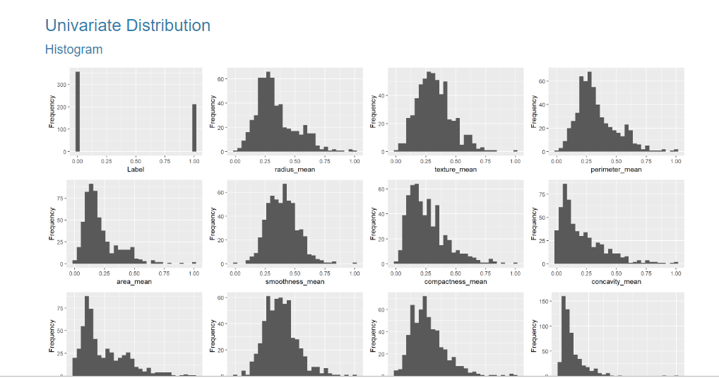
Fig 3: Distribution of features of the train data set
From our histograms I fig 3 above, Most of the features are normally distributed. Comparison of radius distribution by malignancy shows that there is no perfect separation between any of the features; we do have fairly good separations for concave_points, concavity _worst, perimeter_worst, area_mean, perimeter_mean. We do have as well tight superposition for some of the values, like symmetry_se, smoothness_se.

4.1 Correlation Analysis
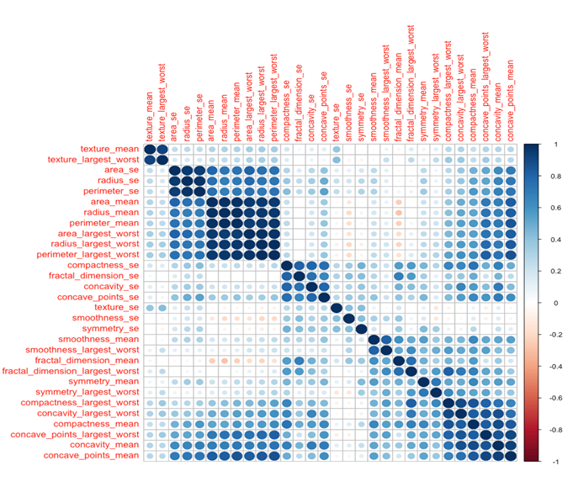
We are also interested in how the 30 predictors relate to each other. To see bivariate relationships among these 30 predictors, we will look at correlations.
Fig 4 shows here are quite a few variables that are correlated. Often, we have features that are highly correlated and those provide redundant information. By eliminating highly correlated features we can avoid a predictive bias for the information contained in these features. This also shows us, that when we want to make statements about the biological/ medical importance of specific features, we need to keep in mind that just because they are suitable to predicting an outcome they are not necessarily causal - they could simply be correlated with causal factors.
I am now removing all features with a correlation higher than 0.9, keeping the feature with the lower mean.
  - Feature Space Reduction
Too many features cost more computational time and memory, which is also known as the “Curse of Dimensionality”. Features in the data set may be correlated. PCA is one of the commonly used statistical tools that can transform possible correlated variables into uncorrelated variables, which is also called principal components (PC). In the process of PCA, deciding an appropriate number of principal components to represent feature space is critical. There are several criteria that can be implemented, such as Kaiser's criterion, scree-plot, and interpretability, etc. A combination of scree-plots is applied in this research to decide the necessary amount of PC, in which a notable drop in the scree plot represents the suitable number of PC and 95% correlation explained. Figure 3 shows PCA results for WBC data. Based on Figure 3a, three out of nine PCs are chosen, and eleven PCs are selected based on Figure 3b, which explains 94.09% of total correlation. For WDBC data, Figure 4a and 4b give scree plot result and correlation interpreted result respectively. Eleven PCs are chosen based on the scree plot, which explains 92.6% of total correlation. And ten PCs are selected based on 95% correlation explained criteria, which explained 95.12% of the total correlation. Obviously, different number of PCs are decided based on different criteria, which inspires us to form different hybrid model with the concern of the PC selection criteria.

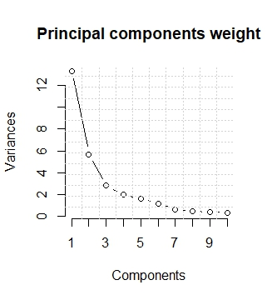

a) Scree plot b) Correlation explained.
Figure 4: Principal component analysis for my data under consideration (WDBC data).
From the above plot, I need 11 principal components to explain more than 0.96 of the variances and 20 to explain more than 0.99. The features with highest dimensions or aligned with the leading principal component are the ones with highest variance. To test whether dimension reduction method can influence prediction effectiveness and accuracy, PCA results are used to build two new hybrid models: SVM and ANN. I choose to make use of the principal components selected based on 95% of correlation explained.

  - Evaluation Performance
In order to compare the performance of these models, accuracy measurement is used, which is given by Equation (1) below, where 𝑇𝑃 ,𝑇𝑁, 𝐹𝑃, and FN represent True Positive, True Negative, False Positive, and False Negative and test accuracy.
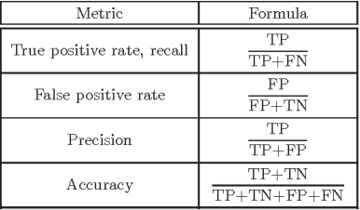
Formula for evaluation Performance

----- eqn(1)

The error rates of the developed models using both classifiers were also determined with the evaluation criteria already discussed.
5 Experimental Results and discussion
In This section, I evaluate the effectiveness of all classifiers in terms of correctly classified instances, incorrectly classified instances and accuracy.
Table 3: comparison of accuracy of the two classifiers
Classifiers | SVM ANN
Correctly classified Instances | 168 162
Incorrectly classified Instances | 1 7
Accuracy (%) | 99.40 95.86

From our results in table 3 above, SVM correctly predicts 168 instances out of 169 instances (105 benign instances that are effectively benign and 63 malignant instance that are malignant), and incorrectly predicted 1 instance (1 instance of benign class predicted as malignant and 0 instances of malignant class predicted as benign). On the other hand, the ANN correctly predicts 162 instances out of 169 instances (101 benign instances that are effectively benign and 61 malignant instances that are malignant), and incorrectly predicted 7 instances (3 instances of benign class predicted as malignant and 4 instances of malignant class predicted as benign) .
That is why the accuracy of SVM is better than ANN and other classification techniques used with lower error rate value
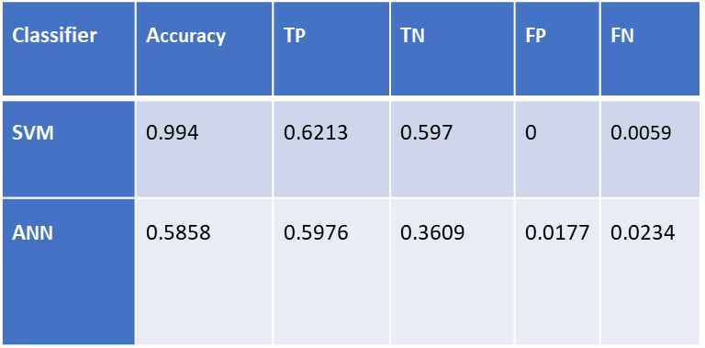
Table 4: Performance evaluation on both models

The table 3 above shows the comparison of accuracies rates for the two classifiers (SVM and ANN) based on the above method as a test method (formula) . The accuracy of SVM (99.40%) is the best classifier and the accuracy obtained by SVM is better than that produced by ANN (0.05858). The FP rate is lower when using SVM classifiers (0 for benign class and 0.005 for malignant class). Table 4 shows the comparison of accuracies for the two classifiers (SVM and ANN) based on the above method as a test method ( formula) . The accuracy of SVM (99.40%) is the best classifier and the accuracy obtained by SVM is better than that produced by ANN. The FP rate is lower when using SVM classifiers (0 for benign class and 0.005 for malignant class).
- Conclusion
There are different data mining techniques that can be used for analytical and the prediction of breast cancer recurrence. An important challenge in data mining and machine learning areas is to build accurate and computationally efficient classifiers for Medical applications. In this study, I made use of two machine learning classification techniques to ascertain; the efficacy of this techniques in predicting the recurrence of breast cancer and then compared the results in terms of efficiency and effectiveness of those algorithms in terms of accuracy, precision, sensitivity and specificity to find the best classification accuracy. The results indicated that SVM are the best classifier predictor with the test dataset compared to ANN.
Acknowledgement
Dr. Nfii Ndikintum being such a model professor to make sure we stay ahead in this changing world of Technology. Dr Samuel Jator for his support feeling the gap of a Dad, where I am today is thanks to his unrelenting effort and “his sixth mile advice”. Dr (Mrs) Eleanor Jator for her mentorship and motherly duties towards me and always making sure I pay attention to details in all I do no matter how relevant it is. I have learn a lot from you, God bless . Special thanks to Dr Mayo for laying the Machine learning foundation for me and always present and ready to help. My course mates who have been there to ensure we all are on the same page and learning pace. To all faculty, I say thank you.

References
- American Cancer Society (2005). "Breast Cancer Facts & Figures 2005–2006" (PDF). Archived from the original on 13 June 2007. http://web.archive.org/web/20070613192148/http://www.cancer.org/downloads/STT/CAFF2005BrFacspdf2005.pdf. Retrieved 2013-02-26.
- American Cancer Society (2007). "Cancer Facts & Figures 2007" (PDF). Archived from the original on 10 April 2007. http://web.archive.org/web/20070410025934/http://www.cancer.org/downloads/STT/CAFF2007PWSecured.pdf. Retrieved 2012-11-26.
- American Cancer Society (2007). "Cancer Facts & Figures 2007" (PDF). Archived from the original on 10 April 2007. http://web.archive.org/web/20070410025934/http://www.cancer.org/downloads/STT/CAFF2007PWSecured.pdf.
- I. Salama, Gouda & Abdelhalim, mohamed b & Zeid, Magdy. (2012). Experimental comparison of classifiers for breast cancer diagnosis. 180-185. 10.1109/ICCES.2012.6408508.
- Shajahaan, S.S; Shanthi, S., Chitra, V.M. (2013). Application of Data Mining Techniques to model Breast Cancer Data. International Journal of Emerging Technology and Advanced Engineering Vol 3, Issue 11, November 2013. ISSN 2250-2459. http://www.ijetac.com pg 362 – 369.
- Shukla, A & Tiwari, Ritu & Kaur, Prabhdeep. (2009). Knowledge Based Approach for Diagnosis of Breast Cancer. 2009 IEEE International Advance Computing Conference, IACC 2009. 6 - 12. 10.1109/IADCC.2009.4808971.
- Polat, Kemal & Güneş, Salih. (2007). Breast cancer diagnosis using least square support vector machine. Digital Signal Processing. 17. 694-701. 10.1016/j.dsp.2006.10.008.
- Fatih Akay, Mehmet. (2009). Akay, M.F.: Support vector machines combined with feature selection for breast cancer diagnosis. Expert systems with applications 36(2), 3240-3247. Expert Syst. Appl.. 36. 3240-3247. 10.1016/j.eswa.2008.01.009.
- Yeh, Wei-Chang & Chang, Wei-Wen & Chung, Yuk. (2009). A new hybrid approach for mining breast cancer pattern using discrete particle swarm optimization and statistical method. Expert Systems with Applications. 36. 8204-8211. 10.1016/j.eswa.2008.10.004.
- Marcano-Cedeño A, Quintanilla-Domínguez J, Andina D. WBCD breast cancer database classification applying artificial metaplasticity neural network. Expert Systems with Applications. 2011 Aug 1;38(8):9573-9.
- https://www.r-project.org/about.html
- https://www.researchgate.net/figure/Captured-images-of-layers-of-glass-with-smears-of-breast-mass obtained-by-FNA-the-parts_fig3_232811011
- Niknejad A, Petrovic D(2013). Introduction to computational intelligence techniques and areas of their applications in medicine. Med Appl Artif Intell 2013;51
- Williams, Kehinde., Idowu, Peter Balogun, Jeremiah Ishola Oluwaranti, Adeniran.(2015).BREAST CANCER RISK PREDICTION USING DATA MINING CLASSIFICATION TECHNIQUES. Transactions on Networks and Communications 3. 10.14738/tnc.32.662
- [1] American Cancer Society (2005). "Breast Cancer Facts & Figures 2005–2006" (PDF).
- http://web.archive.org/web/20070613192148/http://www.cancer.org/downloads/STT/CA FF2005BrFacspdf2005.pdf. 13 June 2007. Retrieved 2013-02-26. [2]
- American Cancer Society (2007). "Cancer Facts & Figures 2007" (PDF). 10 April 2007. http://web.archive.org/web/20070410025934/, http://www.cancer.org/downloads/STT/CA FF2007PWSecured.pdf. Retrieved 2012-11-26.
- Haifeng Wang, Sang Won Yoon, “Breast Cancer prediction using Data Mining Methods”, Pr Proceedings of the 2015 Industrial and Systems Engineering Research Conference, S. Cetinkaya and J. K. Ryan, eds. October 2015.
- M Deepika, L Mary Gladence, and R Madhu Keerthana, “A Review on Prediction Of Breast Cancer Using Various Data Mining Techniques”, Research Journal of Pharmaceutical, Biological and Chemical Sciences, ISSN: 0975-8585, pg-808, Januray- February 2016.
- Peter Adebayo Idowu, Kehinde Oladipo Williams, Jeremiah Ademola Balogun and Adeniran Ishola Oluwaranti, “Breast Cancer Risk Prediction Using Data Mining Classification Techniques”, Transactions on Network and Communication, ISSN: 2054- 7420, Vol. 3, Issue 2, March 10 2015.
- RuiXu, Anagnostopoulos, G.C. And Wunsch, D.C.I.I.,"Multiclass Cancer Classification Using Semi supervised Ellipsoid ARTMAP and Particle Swarm Optimization with Gene Expression Data", IEEE/ACM Transactions On Computational Biology And Bioinformatics, Vol.4, No.1, Pp. 65-77, 2007.
- Suárez-Álvarez, Javier & Fernández-Alonso, Ruben & Muñiz, José. (2013). Self-concept, motivation, expectations, and socioeconomic level as predictors of academic performance in mathematics. Learning and Individual Differences. 30. 10.1016/j.lindif.2013.10.019.
- Shalabi, Luai & Zyad, Shaaban & Al-Kasasbeh, Basil. (2006). Data Mining: A Preprocessing Engine. Journal of Computer Science. 2. 10.3844/jcssp.2006.735.739.
Appendix
Rcodes for the Project.
setwd("C:/Users/jator/OneDrive/Desktop/Capstone")
dat=read.csv("Dataa2.csv")
# load libraries
library("ggplot2")
library("e1071")
library(dplyr)
library(reshape2)
library(corrplot)
library(caret)
library(pROC)
library(gridExtra)
library(grid)
library(ggfortify)
library(purrr)
library(nnet)
library(doParallel)
# parallel processing
registerDoParallel()
require(foreach)
require(iterators)
require(parallel)
dat = dat[,-1]
str(dat)
dat$label[dat$diagnosis=="B"]<-"0"
dat$label[dat$diagnosis=="M"]<-"1"
dat$label=factor(dat$label)
head(dat,10)
str(dat)
levels(dat$diagnosis)
colnames(dat)
## Preprocessing
MaxVal = apply(dat[,2:31], 2, max)
MaxVal
MinVal = apply(dat[,2:31],2, min)
MinVal
dat1 = as.data.frame(scale(dat[,2:31],center = MinVal, scale = MaxVal- MinVal))
head(dat1,10)
Label = as.numeric(dat$label) - 1
data = data.frame(Label, dat1)
head(data,10)
library(DataExplorer)
create_report(data)
### Splitting
library(dplyr)
library(neuralnet)
set.seed(123)
ind = sample(1:nrow(data),400)
train = data[ind,]
test = data[-ind,]
test
dim(train)
dim(test)
allvars = colnames(data)
PredictorVars = allvars[!allvars%in%"Label"]
PredictorVars
PredictorVars = paste(PredictorVars, collapse = "+")
form = as.formula(paste("Label~", PredictorVars, collapse = "+"))
neuralmodel = neuralnet(formula = form, hidden =4, linear.output = F, act.fct = "logistic", data = train)
plot(neuralmodel)

## Predictions Neural Network
output = compute(neuralmodel, test[,2:31])
p1 = output$net.result

## Confusion Matrix for Neural Network
pred1 = ifelse(p1>0.5, 1, 0)
tab1 = table(pred1,test$Label)
tab1
accuracy = (164/169)*100
accuracy
frame = data.frame(pred1, test$Label)
malignant_malignant = sum(frame[,1]==1 & frame[,2]==1)
malignant_benign = sum(frame[,1]==1 & frame[,2] == 0)
benign_malignant = sum(frame[,1]==0 & frame[,2] == 1)
benign_benign = sum(frame[,1]==0 & frame[,2] == 0)
TClass <- factor(c(0, 0, 1, 1))
PClass <- factor(c(0, 1, 0, 1))
Y <- c(benign_benign, benign_malignant, malignant_benign, malignant_malignant)
df <- data.frame(TClass, PClass, Y)
library(ggplot2)
ggplot(data = df, mapping = aes(x = TClass, y = PClass)) +
geom_tile(aes(fill = Y), colour = "white") +
geom_text(aes(label = sprintf("%1.0f", Y)), vjust = 1) +
scale_fill_gradient(low = "blue", high = "red") +
theme_bw() + theme(legend.position = "none") +xlab("True Class") + ylab("Predicted Class")
## SVM Model and confusion matrix
library(e1071)
svm_model = svm(formula = form,data = train)
svm_predictions = predict(svm_model, test[,2:31])
pred2 = ifelse(svm_predictions>0.5, 1, 0)
tab2 = table(pred2,test$Label)
tab2
accuracy_svm = (168/169)*100
accuracy_svm
run
frame1 = data.frame(pred2, test$Label)
malignant_malignant = sum(frame1[,1]==1 & frame1[,2]==1)
malignant_benign = sum(frame1[,1]==1 & frame1[,2] == 0)
benign_malignant = sum(frame1[,1]==0 & frame1[,2] == 1)
benign_benign = sum(frame1[,1]==0 & frame1[,2] == 0)
TClass <- factor(c(0, 0, 1, 1))
PClass <- factor(c(0, 1, 0, 1))
Y <- c(benign_benign, benign_malignant, malignant_benign, malignant_malignant)
df1 <- data.frame(TClass, PClass, Y)
library(ggplot2)
ggplot(data = df1, mapping = aes(x = TClass, y = PClass)) +
geom_tile(aes(fill = Y), colour = "white") +
geom_text(aes(label = sprintf("%1.0f", Y)), vjust = 1) +
scale_fill_gradient(low = "green", high = "red") +
theme_bw() + theme(legend.position = "none") +xlab("True Class") + ylab("Predicted Class")

#### Feature Selection with PCA

pca_df = data[,-1]
pca = prcomp(scale(pca_df))
head(pca$rotation)
summary(pca)
library(reshape2)
library(ggplot2)
library(DataExplorer)
create_report(data)
plot(pca, type = 'l', main = '')
grid(nx = 10, ny = 14)
title(main = "Principal components weight", sub = NULL, xlab = "Components")
box()
comp_loadings = pca$rotation[,1:11]
comp_loadings
comp_loadings = as.matrix(comp_loadings)
plot(comp_loadings)
eigs = pca$sdev^2
frame1 = data.frame(seq(1,30,1),cumsum(eigs / sum(eigs)))
colnames(frame1) = c("Principal_Component", "Variance_Explained")
windows()
ggplot(data=frame1, aes(x=Principal_Component, y=Variance_Explained)) +
geom_line()+ geom_point() +xlab("Principal Component") + ylab("Variance Explained")+
geom_abline(intercept = 0.96, color = "red", slope = 0)

# Visaulizing the
#For machine learning Purposes, I will load packages that is best for the algorithms I will use.

summary(dat1$label)
library(ggplot2)
diagnosis.table <- table(dat1$diagnosis)
colors <- terrain.colors(2)
# Create a pie chart
diagnosis.prop.table <- prop.table(diagnosis.table)*100
diagnosis.prop.df <- as.data.frame(diagnosis.prop.table)
pielabels <- sprintf("%s - %3.1f%s", diagnosis.prop.df[,1], diagnosis.prop.table, "%")
pie(diagnosis.prop.table,
labels=pielabels,
clockwise=TRUE,
col=colors,
border="gainsboro",
radius=0.8,
cex=0.8,
main="frequency of cancer diagnosis")
legend(1, .4, legend=diagnosis.prop.df[,1], cex = 0.7, fill = colors)
#Break up columns into groups, according to their suffix designation
#(_mean, _se,and __worst) to perform visualisation plots off.
data_mean <-dat[ ,c("diagnosis", "radius_mean", "texture_mean","perimeter_mean", "area_mean", "smoothness_mean", "compactness_mean", "concavity_mean", "concave.points_mean", "symmetry_mean", "fractal_dimension_mean" )]

data_se <-dat[ ,c("diagnosis", "radius_se", "texture_se","perimeter_se", "area_se", "smoothness_se", "compactness_se", "concavity_se", "concave.points_se", "symmetry_se", "fractal_dimension_se" )]

data_worst <- dat[ ,c("diagnosis", "radius_worst", "texture_worst","perimeter_worst", "area_worst", "smoothness_worst", "compactness_worst", "concavity_worst", "concave.points_worst", "symmetry_worst", "fractal_dimension_worst" )]

#Plot histograms of "_mean" variables group by diagnosis
ggplot(data = melt(data_mean, id.var = "diagnosis"), mapping = aes(x = value)) +
geom_histogram(bins = 10, aes(fill=diagnosis), alpha=0.5) + facet_wrap(~variable, scales = 'free_x')

ggplot(data = melt(data_se, id.var = "diagnosis"), mapping = aes(x = value)) +
geom_histogram(bins = 10, aes(fill=diagnosis), alpha=0.5) + facet_wrap(~variable, scales = 'free_x')
##### PCA #####
# Create train and test sets
train_indices = sample(1:nrow(dat1),400)
train_set = dat[train_indices,(-1)]
train_labels = dat[train_indices,1]

# Perform PCA on the train set
pca_one = prcomp(train_set)
train_set = as.matrix(train_set)
# Run the code below and observe that the first seven principal components account for
# approximately 90% of the variance in the data
summary(pca_one)
data.class(dat)
library(tidyr)
library(PCAmixdata)
library(pcaGoPromoter)
library(ellipse)
library(corrplot)
corMatMy <- cor(train_set[, 2:30])
corrplot(corMatMy, order = "hclust")
set.seed(27)
# Retrieve the loadings for the first seven principal components
comp_loadings = pca_one$rotation[,1:7]
comp_loadings = as.matrix(comp_loadings)

# Transform the data using the loadings. Notice that there are only seven columns in the transformed
# test set. That is, instead of using the original 30 features we instead use
# the seven principal components reducing the dimensionality of the feature space.
# Also, the original 30 features had severe multicolinearity problems. The seven principal components
# We are now using as features have zero correlation by design, eliminating our multicolinearity problem.
train_set_transformed = train_set %*% comp_loadings

# Create the test set
test_set_features = dat[-train_indices,(-1)]
test_set_labels = dat[-train_indices,1]

test_set_features = as.matrix(test_set_features)
# We transform the test set features USING THE SAME LOADINGS WE ESTIMATED FROM THE TRAINING DATA.
# If we redid principal component analysis on the test set features we would have a poor accuracy rate.
# If we did principal component analysis and then created a test set from the transformed matrix then we
# would have a higher accuracy rate then we should. We must estimate the principal components from the
# training data and then apply the same transformation to the test set data.
test_set_features_transformed = test_set_features %*% comp_loadings

# This creates a plot of the proportion of variance explain as a function of the number of principal components
eigs = pca_one$sdev^2
frame1 = data.frame(seq(1,30,1),cumsum(eigs / sum(eigs)))
colnames(frame1) = c("Principal_Component", "Variance_Explained")

ggplot(data=frame1, aes(x=Principal_Component, y=Variance_Explained)) +
geom_line()+ geom_point() +xlab("Principal Component") + ylab("Variance Explained")

library(ggplot2)
library(ISLR)
library(e1071)
# This lands somewhere around 95% accuracy
svm_model = svm(train_labels ~., train_set_transformed)
svm_predictions = predict(svm_model, test_set_features_transformed)
frame = cbind(svm_predictions,test_set_labels)
svm_accuracy = sum(frame[,1] == frame[,2])/nrow(frame);svm_accuracy
svm_pred = predict(svm_model, test_set_features_transformed)
malignant_malignant = sum(frame[,1]==2 & frame[,2]==2)
malignant_benign = sum(frame[,1]==2 & frame[,2] == 1)
benign_malignant = sum(frame[,1]==1 & frame[,2] == 2)
benign_benign = sum(frame[,1]==1 & frame[,2] == 1)

TrueClass <- factor(c(0, 0, 1, 1))
PredictedClass <- factor(c(0, 1, 0, 1))
Y<- c(benign_benign, benign_malignant, malignant_benign, malignant_malignant)
df <- data.frame(TClass, PClass, Y)
df
library(ggplot2)
ggplot(data = df, mapping = aes(x = TClass, y = PClass)) +
geom_tile(aes(fill = Y), colour = "red") +
geom_text(aes(label = sprintf("%1.0f", Y)), vjust = 1) +
scale_fill_gradient(low = "green", high = "red") +
theme_bw() + theme(legend.position = "none") +xlab("True Class") + ylab("Predicted Class")

library(neuralnet)
library(nnet)

# This numerically labels the benign and malignant variables to 0/1 encoding
# This produces somewhere around 95% accuracy as well
train_labels = as.numeric(train_labels) - 1
test_set_labels = as.numeric(test_set_labels) - 1

nn2 = nnet(train_labels ~., data = train_set_transformed, size=10,entropy=TRUE)

predictions = predict(nn2, test_set_features_transformed)
predictions[predictions < 0.50] = 0
predictions[predictions > 0.50] = 1

frame = cbind(test_set_labels, predictions)
accuracy = sum(frame[,1] == frame[,2])/nrow(frame);accuracy
# Plot of the neural network
library(nnet)
plot(nn2)
plotnet(mod_in, x_names = NULL, y_names = NULL,
skip = FALSE, ...)

malignant_malignant = sum(frame[,1]==1 & frame[,2]==1)
malignant_benign = sum(frame[,1]==1 & frame[,2] == 0)
benign_malignant = sum(frame[,1]==0 & frame[,2] == 1)
benign_benign = sum(frame[,1]==0 & frame[,2] == 0)

TClass <- factor(c(0, 0, 1, 1))
PClass <- factor(c(0, 1, 0, 1))
Y <- c(benign_benign, benign_malignant, malignant_benign, malignant_malignant)
df <- data.frame(TClass, PClass, Y)
df
library(ggplot2)
ggplot(data = df, mapping = aes(x = TClass, y = PClass)) +
geom_tile(aes(fill = Y), colour = "white") +
geom_text(aes(label = sprintf("%1.0f", Y)), vjust = 1) +
scale_fill_gradient(low = "blue", high = "red") +
theme_bw() + theme(legend.position = "none") +xlab("True Class") + ylab("Predicted Class")

